How To Make Repository In GitHub

1. We have to Sign Up in the GitHub Platform Or Log in

[www.GitHub.com](http://www.GitHub.com)

1. Once We log in then Got to the Home Page of GitHub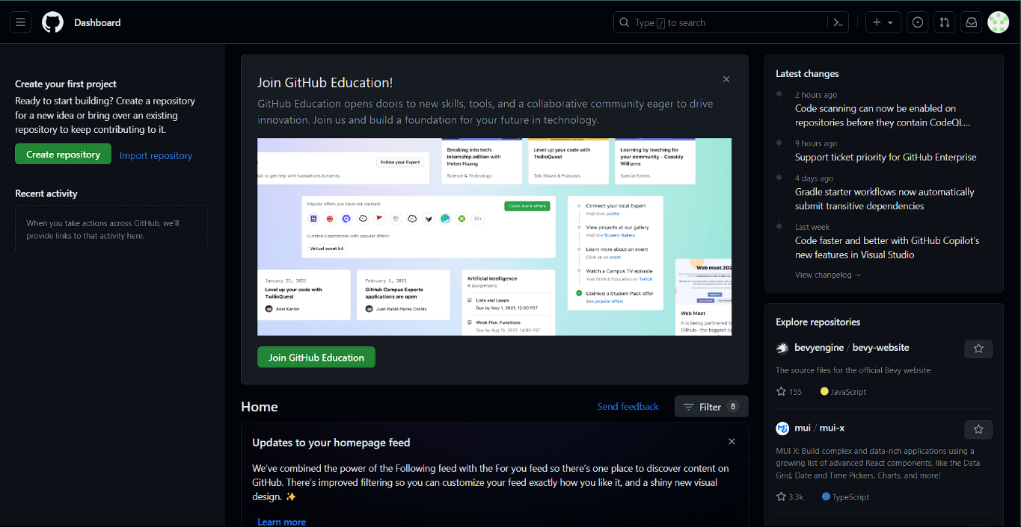

Now, To make repository click on the Create repository on left panal.

1. Now, We have to name Our repository and select option.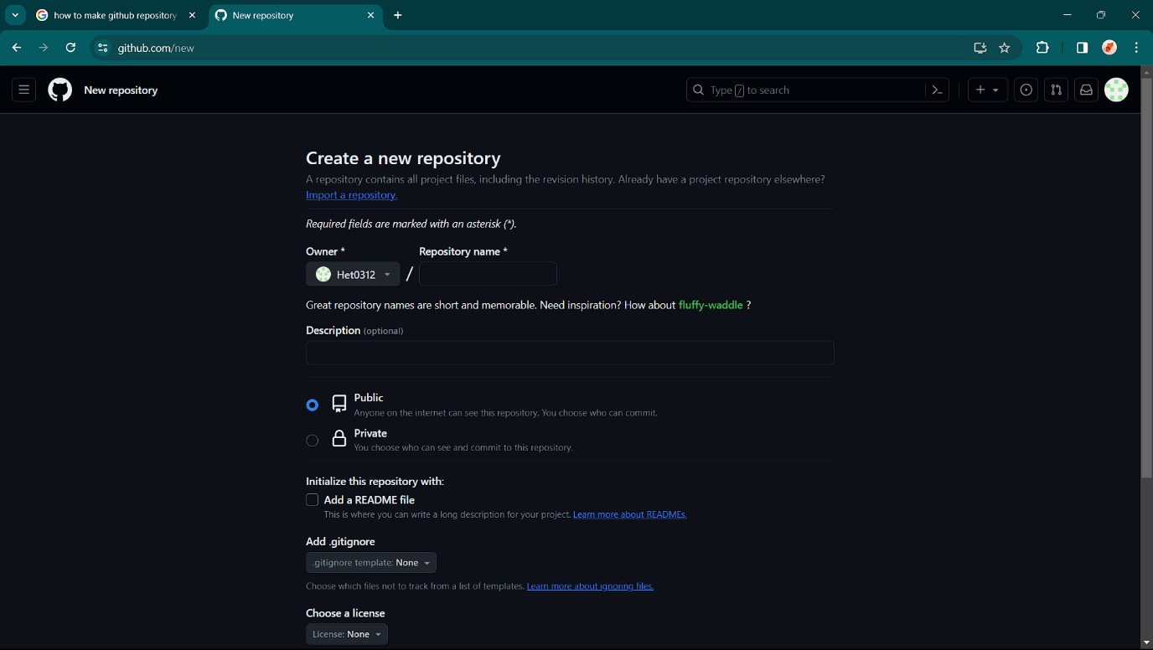

Make it Public so other people can also see the repository and access.

1. Once the repository is created then we have to make two folder to do the we have to choose add file and create new file.

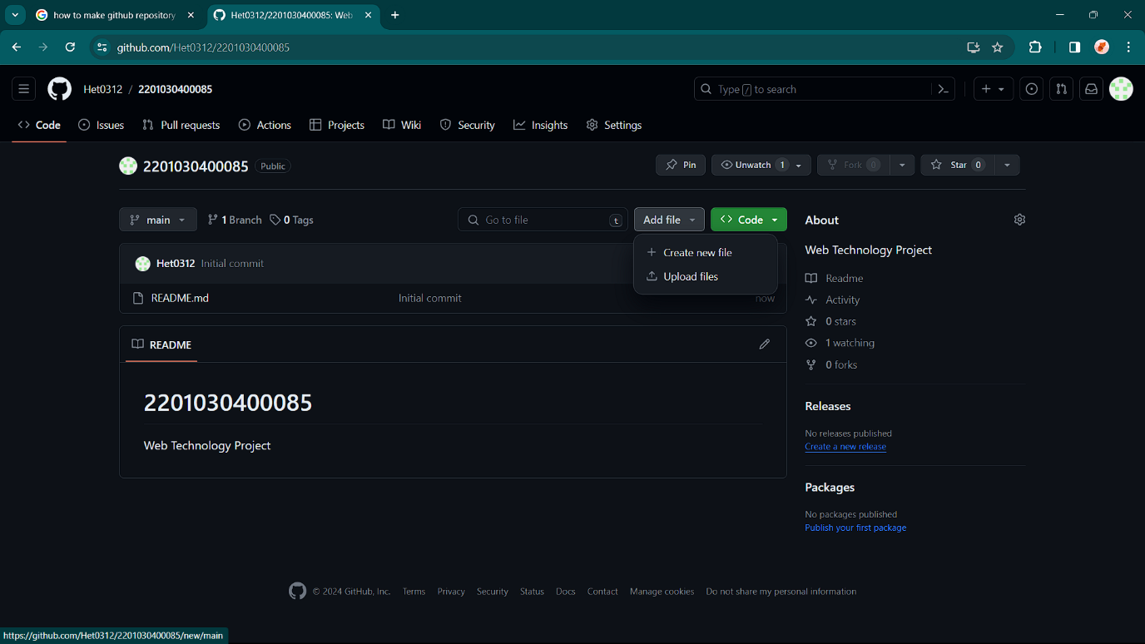

1. Write the name of the folder and at the end put the “ / “ to create the folder if you did not put at the end it just create a normal file and not the folder.

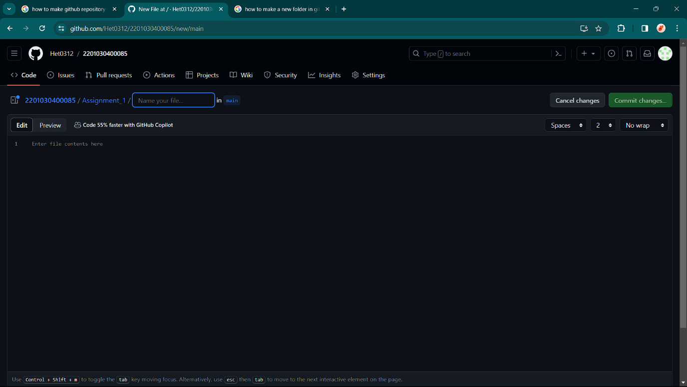

After doing that click on the Commit change to apply the change.

1. At the end we end Up having Our repository with Two folder.